FORENSIC PATHOLOGIST SAN BERNARDINO COUNTY SHERIFF-CORONER DEPARTMENT
The San Bernardino County Sheriff-Coroner is seeking per diem or part time forensic pathologists. Duties and responsibilities include: performing autopsies, providing the determination of the cause and manner of death, timely completion of autopsy reports, and providing expert testimony (if needed).
Days and hours of operation of the morgue are Monday through Friday from 8 am to 5 pm, and the forensic pathologist will work when available. The forensic pathologist will perform complete autopsies, except for homicides and infants. Compensation is by the case, and payment for the cases will be accomplished after completion of the autopsy reports. Expenses, travel, and accommodation are not covered. As an added benefit, the position is covered by the County’s Public Liability Insurance.
Qualified candidates must possess a valid physician’s and surgeon’s license issued by the state of California and board certification in Anatomic and Forensic Pathology from the American Board of Pathology.
For all qualified candidates, background check and polygraph will be conducted. (In order to be employed by the San Bernardino County Sheriff’s Department, qualified candidates must pass a background check and polygraph.)
San Bernardino County has a population of over two million and is located east of Los Angeles. It borders Nevada and Arizona and is the largest county in the contiguous United States. In 2018, the Coroner Division, which currently includes three full-time forensic pathologists and two part-time forensic pathologists, performed approximately 1500 forensic autopsies.
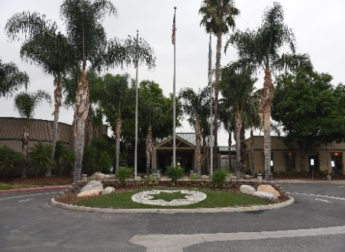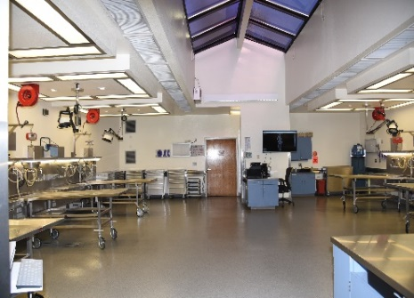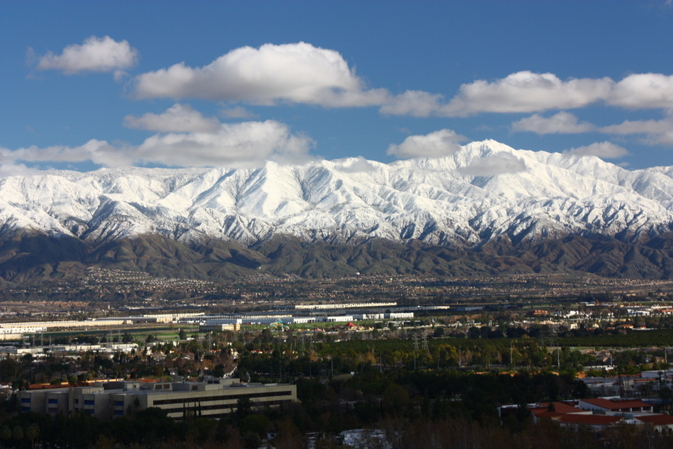
If you are interested and would like to submit your resume/curriculum vitae, please contact:
Dr. Chanikarn Changsri
Chief Forensic Pathologist
Email: cchangsri@sbcsd.org
Phone: (909) 387-2978
Address: 175 S. Lena Rd, San Bernardino, CA 92415

