Montana

Deputy Medical Examiner

  - Looking for a different opportunity?
The Montana Department of Justice Forensic Science Division Medical Examiner’s Office is seeking applicants for Deputy Medical Examiner at our Billings Regional facility where you have the opportunity to work with county coroners to promote death investigation throughout the state. Are fewer crowds, less traffic, affordable cost-of-living, four seasons, outdoor activities and local cultural activities appealing to you? If so this is an excellent opportunity to combine your professional and personal goals.

Brief description and Listing link
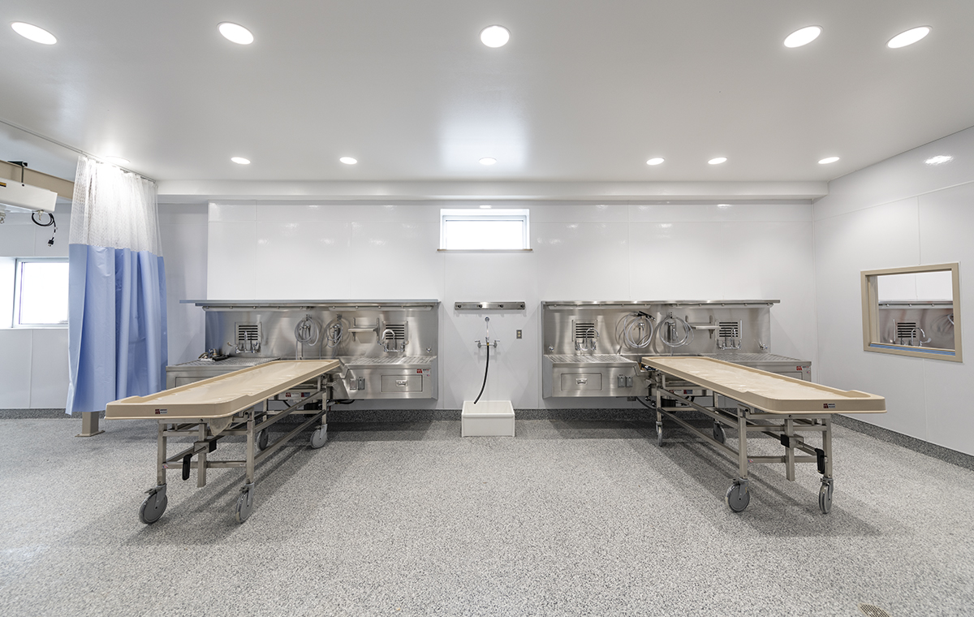

Job Overview

Position title: Deputy Medical Examiner

Location: Billings, Montana

Salary: $102.51 hourly wage (213,220 annual salary)

Starting date: October-November 2020 desired and negotiable

Application period closure: Current offering closes August 23, 2020 but will be extended if necessary

Job Requirements: Board Certification in forensic pathology preferred or board eligibility in forensic pathology (must become board certified within two years)

Workload: Current workload approximately 180 postmortem examinations per year/pathologist

Benefits: Medical, dental and vision coverage; retirement plans; paid vacation accrued at 120 hours per year, sick accrued at 110 hours per year and holidays (11 holidays per year); employee assistance program

Job listing: https://mtstatejobs.taleo.net/careersection/200/jobdetail.ftl?job=20141719&tz=GMT-06%3A00&tzname=America%2FDenver

Additional information: http://statecareers.mt.gov

