COUNTY OF SHASTA
INVITES APPLICATIONS FOR THE POSITION OF

FORENSIC PATHOLOGIST

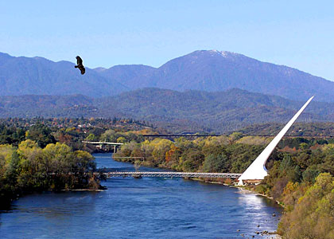

CURRENT VACANCY IS WITHIN THE SHERIFF’S OFFICE

SEE “SPECIAL REQUIREMENT” SECTION REGARDING
POSSESSION OF A PROFESSIONAL LICENSE

SKILLS OR EXPERIENCES LISTED UNDER THE IDEAL CANDIDATE
STATEMENT MAY ALSO BE USED TO SCREEN APPLICATIONS

APPLICATIONS WILL BE REVIEWED WEEKLY UNTIL CURRENT VACANCY IS FILLED

FINAL FILING DATE: ** CONTINUOUS **

SALARY INFORMATION
$16,304 - $20.809 APPROXIMATE MONTHLY* / $94.06 - $120.05 APPROXIMATE HOURLY*
*Please visit https://co.shasta.ca.us/MOUs and refer to the Shasta County Personnel Rules and the Confidential Cost of Living Increases for future salary increases.

ABOUT THE POSITION
Under the administrative direction of the Chief Deputy Coroner, will perform forensic pathology services, general pathology services, and related medical functions to determine cause and manner of death; and performs other related duties as required.

DISTINGUISHING CHARACTERISTICS
The incumbent in this position is appointed by the Sheriff-Coroner and, as a licensed physician and surgeon specializing in forensic pathology, will be responsible for conducting specialized autopsies to determine cause and manner of death. This position is an unclassified, at will position.

EXAMPLES OF DUTIES
Responds to death scenes as required to make preliminary findings as to causes, circumstances, and manner of death; assists in activities concerned with the collection and preservation of evidence; establishes standards for and conducts autopsies to determine the cause, circumstances, and manner of death; interprets reports prepared by physicians, pathologists, and toxicologists; confers with medical and investigative personnel in making determinations as to the cause and circumstance of death; consults with law enforcement officers, the District Attorney, and attorneys in the preparation of court cases; testifies in court; meets with families of deceased to discuss medical aspects of cases; prepares reports of findings; provides administrative direction and oversight to autopsies conducted on a contract basis; carries out departmental operational and administrative policy; trains staff.

QUALIFICATIONS
Any combination of education and experience sufficient to directly demonstrate possession and application of the following:

Knowledge of: Current methods and technology in forensic pathology and related scientific aspects of death investigations; procedures followed in criminal investigative work; principles of training.

Ability to: Perform specialized autopsies to determine cause and manner of death; show compassion and sensitivity in dealing with the kin of deceased; testify articulately and accurately in court; establish and maintain cooperative working relationships with medical, legal, and law enforcement administrators, attorneys, officials, and agencies; train staff; prepare detailed and accurate reports and present findings; work long and irregular hours when needed.

SPECIAL REQUIREMENTS

- Possession of a valid California driver license.
- Possession of a valid Physicians and Surgeons Certificate issued by the California State Board of Medical Examiners at the time of hire

PHYSICAL DEMANDS AND WORK ENVIRONMENT

The physical demands and work environment described here are representative of those that must be met by an employee to successfully perform the essential functions of this job. Reasonable accommodations may be made to enable individuals with disabilities to perform the essential functions.
While performing the duties of this job, the employee is regularly required to talk or hear. The employee frequently is required to walk; sit; use hands to finger, handle, or feel objects, tools, or controls; and stoop, kneel, crouch, or crawl. The employee is occasionally required to stand, reach with hands and arms, climb or balance, and taste or smell.
The employee must frequently lift and/or move more than 100 pounds and occasionally lift and/or move up to 100 pounds. The employee must walk and carry heavy weight on rough and/or uneven terrain and move/lift dead persons.
Specific vision abilities required by this job include close vision, distance vision, color vision, peripheral vision, depth perception, and the ability to adjust focus.

OTHER CONSIDERATIONS

- All new employees are required to have their paycheck directly deposited to a bank account.
- Some positions may require a valid California driver's license and acceptable driving record according to County policy.
- Reasonable accommodations may be made for those persons who are disabled under the Americans with Disabilities Act to perform the essential functions of the position.
- As part of the selection process, all individuals provided with a preliminary offer of employment with Shasta County will be subject to a background investigation, including a criminal history check (primarily completed through the taking of fingerprints). An image of your fingerprints will be captured and sent to the California Department of Justice (DOJ) and the Federal Bureau of Investigation (FBI). The resulting report of your conviction history, (if any), will be evaluated along with the other information received in connection with your application. Except as otherwise required by law, a criminal conviction will not necessarily disqualify you from the position. The nature of the offense, the date of the offense, the surrounding circumstances, and the relevance of the offense to the position applied for may, however, be considered.
- Based on the results of the background investigation and criminal history check, applicants may then be provided with an offer of employment conditioned on the results of a medical examination, which includes drug/alcohol testing.
- Shasta County participates in E-Verify. For more information click here. If you do not have internet access, contact Personnel at (530) 225-5515 to request a flier.
- In accordance with Government Code Section 3100, County employees, in the event of a disaster are considered disaster workers and may be asked to respond accordingly.
- Employees in this classification are covered under the CalPERS retirement program. Depending on the provisions of the California Public Employees’ Pension Reform Act (PEPRA) and other applicable laws, an employee in this classification will be covered under one of the following CalPERS retirement formulas: (1) 2% at 55, (2) 2% at 60, or (3) 2% at 62. An employee in this classification will also contribute up to 7.75% of his/her pay to this plan, or will contribute such other amount to the plan as authorized by PEPRA and other applicable laws. Please visit our employees benefit page at Employee Benefits for additional information regarding benefits and CalPERS coverage information. The provisions in this flyer and on the County’s website are for information purposes only. To the extent the provisions of the flyer or the County’s website are inconsistent with PEPRA and other applicable laws, PEPRA and other applicable laws shall govern.

ABOUT SHASTA COUNTY
Shasta County covers a large geographic area that includes rivers, lakes, and mountains that offer an abundance of recreational opportunities. An eight-mile river trail, numerous community parks, a local museum alliance and continuous community events contribute to the quality of life. Sacramento is 160 miles to the south and the coast is 150 miles to the west. Shasta Lake, located just a few miles north of Redding, is a play land for water sports enthusiasts and vacationers. Lake Shasta offers 365 miles of shoreline and plenty of opportunities for hiking, mountain biking, fishing, sightseeing and wildlife viewing.

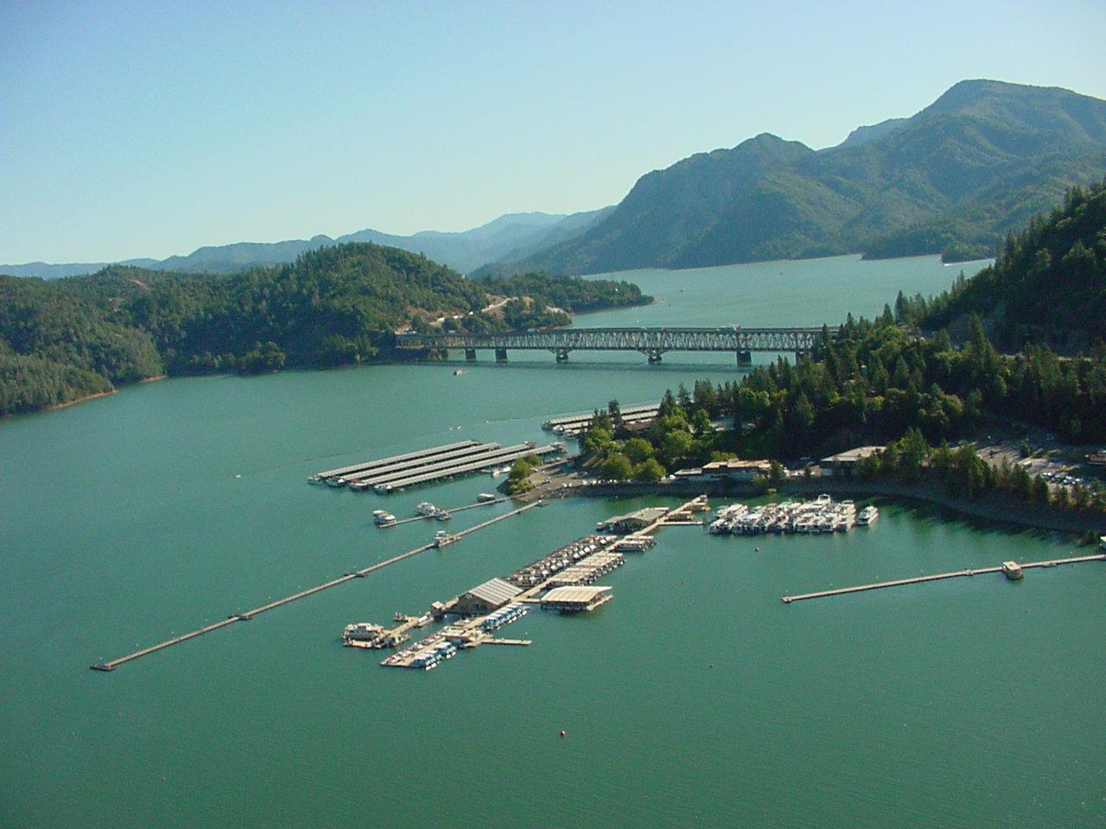
With its natural beauty, affordable housing, excellent educational system, abundance of recreational opportunities, and excellent quality of life, Shasta County is a great place to live, work, and raise a family.

SALARY & BENEFITS
- Salary: $16,304 - $20.809 APPROXIMATE MONTHLY* / $94.06 - $120.05 APPROXIMATE HOURLY*
- Holidays: 12 days per year.
- Vacation: 10 days/year first 3 years; 15 days/year 4-9 years; 17 days/year 10-15 years; 20 days/year 16 years and thereafter.
- Sick Leave: 12 days per year with a generous pro rata payoff at termination after at least 5 years
- Retirement: CalPERS, coordinated with Social Security.
- Insurance: Medical and dental plan, with the County paying for most of the employee and a portion of the dependent cost; a vision plan, a fully-paid life insurance policy and long-term disability plan
- Other: Deferred Compensation plan, IRC Section 125 plan, and credit union membership available.

APPLICATION & SELECTION PROCEDURES

Shasta County Personnel will accept applications and responses to the supplemental questions until current vacancy has been filled. A Resume and/or Cover Letter will be accepted in addition to the application form but will not serve as a substitute for a completed application. It is not acceptable to complete the application with statements such as, “Refer to Resume and/or Cover Letter,” or “See Attached Resume and/or Cover Letter” the employment application must be completed in its entirety prior to submission. Incomplete applications will not be processed. Closing date postmarks or faxes will NOT be accepted. This recruitment will establish a list that may or may not be used by other departments. Prior applicants must reapply to be considered.

Applicants will be screened and those considered best qualified will be invited to appear for an oral and/or written examination. Meeting the announced requirements does not guarantee inclusion into the selection process. Depending upon the number of applications received, the selection process may consist of additional application screening, written and/or practical exam(s), oral interview, or any combination thereof.

Applicants are encouraged to apply on-line at apply online or submit an application to the Shasta County Personnel Office.

Arrangements may be made to accommodate applicants with disabilities. Requests for accommodations may be made to the Shasta County Personnel Office by the filing deadline posted on this bulletin. Shasta County does not discriminate on the basis of disability. If you feel you are being denied service based on a disability, our ADA Coordinator may be reached at (530) 225-5515; relay service (800) 735-2922; fax (530) 225-5345.

SHASTA COUNTY IS AN EQUAL OPPORTUNITY EMPLOYER
Shasta County Personnel
1450 Court Street, Suite 348; Redding, CA 96001; (530) 225-5515

JB694_SO_030321
kjl

