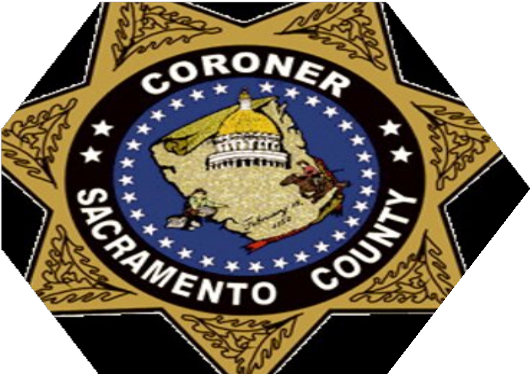

FORENSIC PATHOLOGIST LEVEL I/II

SACRAMENTO COUNTY CORONER'S OFFICE

Sacramento County is an Equal Opportunity Employer

SACRAMENTO COMMMUNITY

Sacramento County covers 984 square miles and is home to the California state capital, 1.5 million residents and seven incorporated cities: Citrus Heights, Elk Grove, Folsom, Galt, Isleton, Rancho Cordova, and Sacramento. The population of Sacramento County's unincorporated area is approximately 589,000.

Residents in Sacramento County have a variety of recreational options to choose from. The County is home to more than 15,000 acres of parks; fishing, boating, windsurfing, and rafting opportunities are available to water enthusiasts; and picnic sites, golfing, guided natural and historic tours are steps away from the multi-use trail. Opportunities for road and mountain biking are plentiful as well. With its close vicinity to local agriculture, County residents also have an extraordinary selection of local food, wines, and beers.

Sacramento County is one of the most affordable home-buying metropolitan areas in the state with a skilled workforce, high graduation rates, and college-educated residents. The County is a leader in the 21st- century economy with growing advanced manufacturing, agriculture and food, clean energy technology, information and communications technology and life sciences.

Visit us at www.SacramentoCounty.net

THE COUNTY OF SACRAMENTO

The County of Sacramento was incorporated in 1850 in response to the needs of a growing population and was one of the original 27 counties of California. In 1933, the Sacramento County Charter was established, along with the County Executive position.

The County is governed by five members of the Sacramento County Board of Supervisors, elected on a non-partisan basis to serve staggered four-year terms, each representing one of the five districts. The County Executive is responsible to the Board for planning, organizing and directing County activities. Other elected officials include the Assessor, District Attorney and the Sheriff.

In 1972, an amendment to the County Charter was implemented to organize the County on an agency basis for more effective administration of functions for which the County Executive is responsible to the Board of Supervisors. Approved by the electorate, the amendment established agency heads to groups of County Departments. The four agencies within the County, which report to the County Executive are Administrative Services, Community Services, Public Safety and Justice, and Social Services. Sacramento County has more than 30 departments and offices that provide services to County residents.

The County is responsible, pursuant to the County Charter or ordinances, or by state or federal mandate, to provide health and welfare, criminal justice and municipal services (including law enforcement), as well as other services to County residents. Major services include the Airport System, Animal Care and Regulation, Clerk Recorder, Criminal Justice, Coroner, Health and Welfare, Property Tax System, Regional Parks, Public Safety and Justice Agency, Sheriff, Transportation, Waste Management and Recycling, Voter Registration and Water Resources.

The County's total operating budget for 2021-22 is over $6.5 billion, and there are more than 12,700 full-time employees.

SACRAMENTO COUNTY CORONER'S OFFICE
The Coroner’s Office is part of the Public Safety and Justice Agency which oversees the Conflict Criminal Defender, Probation, Coroner, and the Public Defender; serves as liaison to the Offices of the Sheriff and District Attorney and the Law Library; and coordinates with the Office of the Inspector General, Superior Court, Criminal Justice Cabinet, and the Community Corrections Partnership.

The Sacramento County Coroner's Office is responsible for determining the cause and manner of death through careful examination of the deceased and other significant evidence. This duty is carried out with respect for the deceased and compassion for the families as they deal with the processes involved in bringing closure to their loss.

The staffing is comprised of a Coroner, a Chief Forensic Pathologist, 3 full-time Forensic Pathologists, 2 Supervising Deputy Coroners, 12 Deputy Coroners, 12 Coroner technicians, and 4 administrative support staff. Contracts are maintained with Forensic Pathologists, an Odontologist, a Forensic Anthropologist, a Forensic Artist, and other specialists. It also consists of full-time in-house Pediatric and Neuropathologists on staff for consultation. In 2019, 1,434 exams (766 autopsies) were conducted by full-time and contracted Forensic Pathologists and University of California, Davis residents.

The Department has a contract with the University of California Davis. The forensic pathologists are volunteer faculty with the Department of Pathology. Pathology residents rotate monthly through the department performing hospital and forensic cases. The forensic pathologists have privileges at the UC Davis medical center and full access to the university library and CME lectures.

The current office was built and opened in 1996. The morgue is large enough to accommodate 8 autopsies being performed at one time with 2 specialized rooms: a Homicide room with a connected viewing room and a dedicated infectious disease room. In an effort to keep all staff safe, the entire morgue was outfitted with state-of-the-art UV lighting in 2020.

The Department of Coroner is the Region IV Coordinator. In that role, staff have participated in two mass fatality incidents in the last 3 years and is the first office to utilize Rapid DNA in a mass fatality event.

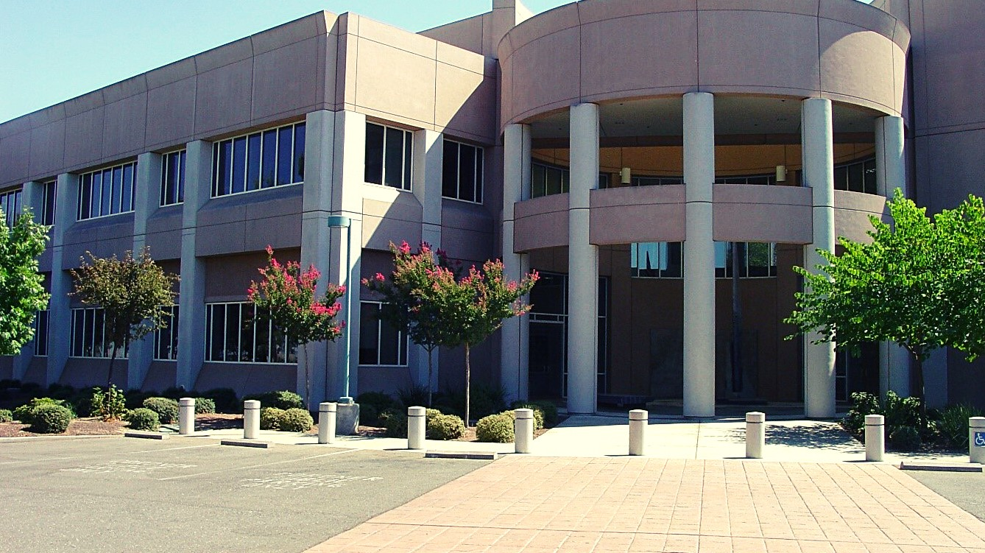
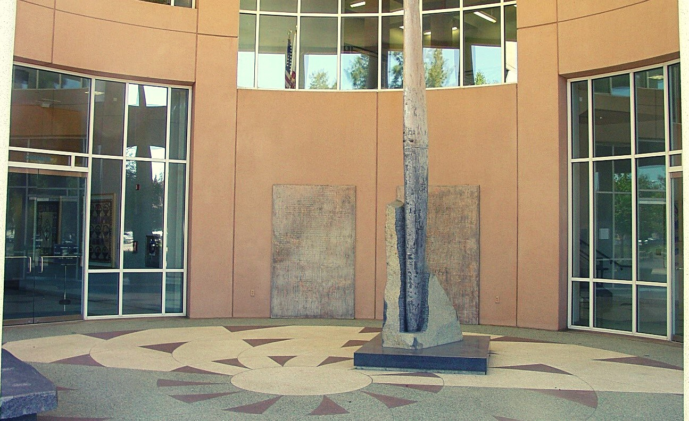
The Department is currently working on adding a Pathology Assistant job classification to perform routine forensic autopsies. This classification should be in place before the end of FY 2021/22.

DESCRIPTION OF DUTIES
FORENSIC PATHOLOGIST LEVEL I/II

Duties:
Performs a wide variety of medical services including autopsy, external examination of bodies, evaluation of medical records, dictation of autopsy and examination reports and oversees completion of transcribed reports.
Directs and ensures the preservation of physical and medical evidence in accordance with policy, professional standards, and State regulations and ensures chain of custody. Interprets toxicology and laboratory results; analyzes tissue/body fluid slides with microscope and interprets findings.
Graduates from an accredited Neuropathology or Pediatric Fellowship Program may be assigned to provide neuropathology consultation by providing specialty examinations and issuance of report of findings.
Provides "On-Scene" consultation to Deputy Coroners and other law enforcement agencies as needed.
Trains residents in anatomic and forensic pathology; provides in-service education to staff and other agency training.
Coordinates interaction with consultants.
Provides advisory and consultative services to Department staff, various governmental bodies, and to Public Health Service professionals including County Child Death Review Team.
Participates in countywide death review teams and hospital peer review committees concerning traumatic deaths.
Communicates with families and other interested parties to explain findings. Maintain cooperative relationships with transplant organizations.
Prepares and presents medical findings in court, to judicial agencies, legal representatives, and other interested parties.
Prepares executive-level correspondence and reports. Participates in various research projects.
Assists in developing policies and procedures.
Keeps informed of new and improved methods in Forensic Pathology and medicine and instructs the professional and technical staff in such methods.

DESCRIPTION OF KNOWLEDGE OF:

FORENSIC PATHOLOGIST LEVEL I/II

Knowledge of:
Procedures, techniques, and equipment utilized in forensic medicine, including medico-legal autopsy, forensic toxicology, ballistics/firearm examination, trace evidence, forensic serology, forensic anthropology, DNA technology and interpretation of histology and clinical chemistry necessary to determine the circumstances, cause, manner, and time of death
Rules and regulations applicable to court testimony Forensic evidence collection techniques and procedures
Laws, legal codes, court procedures, precedents, and government regulations

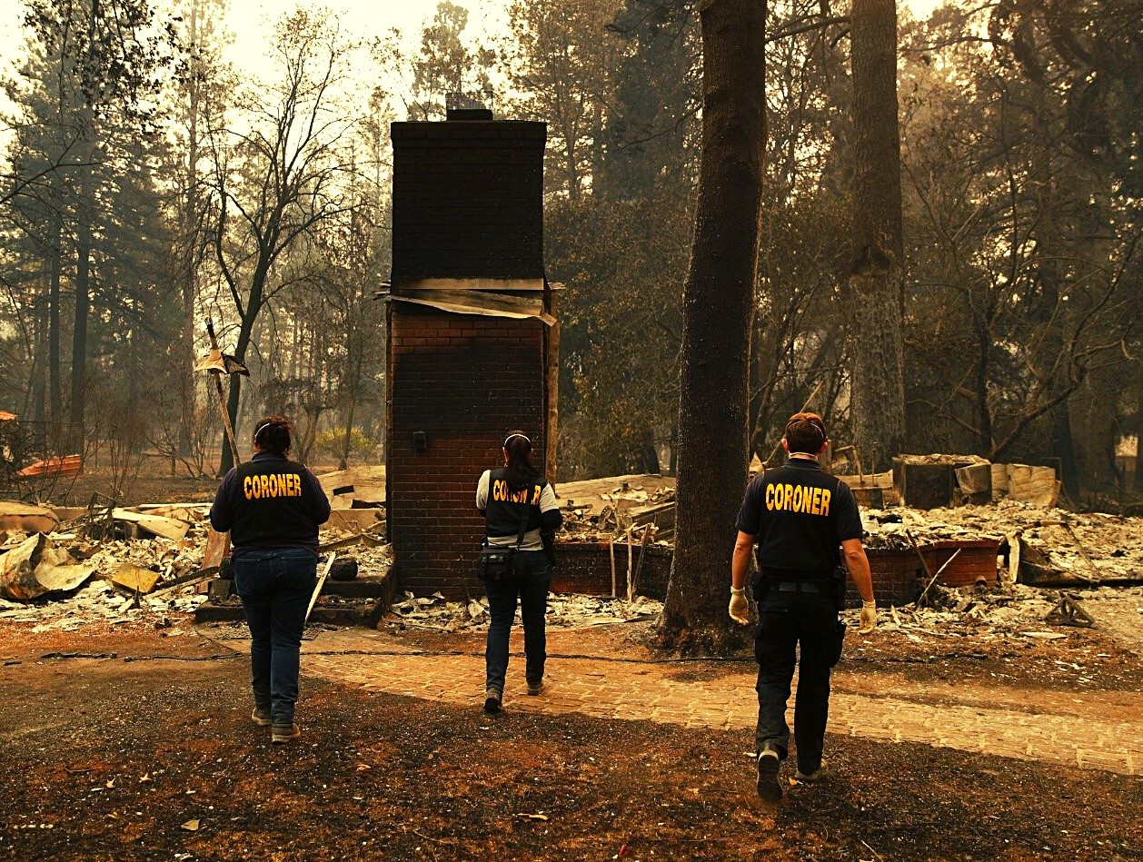

FORENSIC PATHOLOGIST LEVEL I/II
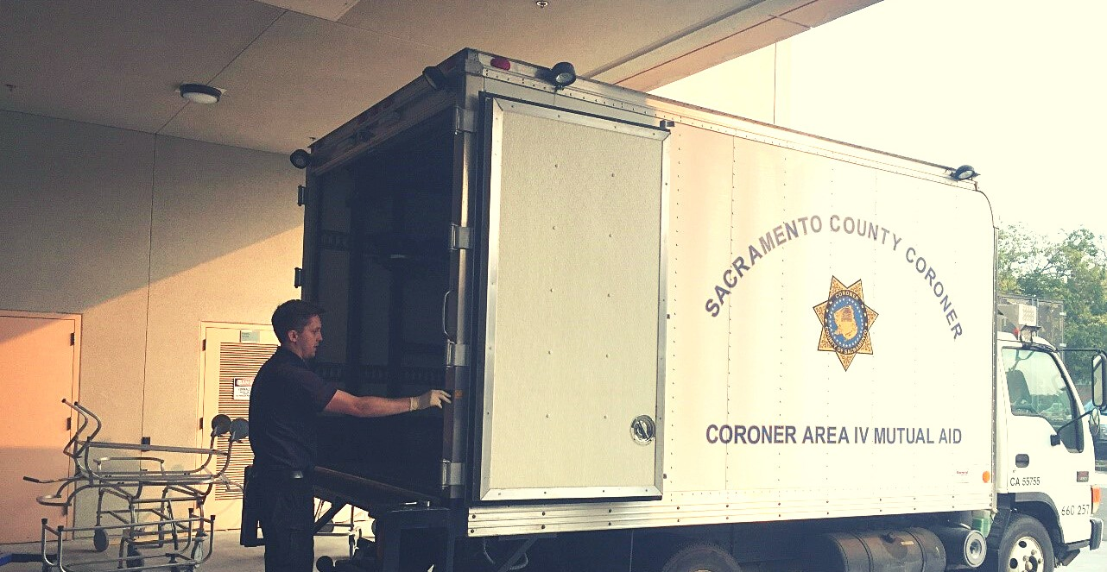
This is a single class with two salary levels. The level at which initial appointments are made are at the discretion of the appointing authority.

Forensic Pathologist (Level I) is the entry-level of this class. Incumbents at this level are not yet Board certified in forensic pathology. Working under general supervision, incumbents function as a forensic pathologist and vital team members working on the daily caseload, further refining their skills in medico-legal death investigation and cause and manner of death. At the discretion of the appointing authority, incumbents may advance to the higher level after obtaining Board certification in forensic pathology.

Forensic Pathologist (Level II) is the experienced level in this specialized class and the targeted competency and performance level expected of all Forensic Pathologists. Incumbents proficiently perform the full-scope of Forensic Pathology activities. Level II differs from Level I in that the incumbents in Level II are Board certified in forensic pathology and exercise a higher level of independent judgment and discretion consistent with department policies, procedures, and guidelines.

Workload: 250-300 Examinations annually, which includes all case classes (Autopsy and External examinations).

UC Davis Medical Center, Dept of Pathology Faculty Appointment:
The Forensic Pathologist will be granted a volunteer faculty appointment with the UC Davis Medical Center through the Dept of Pathology, for the purpose of staffing residents on both hospital and forensic autopsies. The hospital autopsies average less than 100 cases per year with a current caseload of approximately 60 cases per year total.

The ideal candidate will:
THE IDEAL CANDIDATE & DESIRABLE QUALIFICATIONS
Have a Doctorate of Medicine Degree from an approved medical school or osteopathic school.
Have a valid, unrestricted California Physician and Surgeons license.
Be board certified in Anatomic & Clinical or Anatomic Pathology by the American Board of Pathology and be in good standing.
Have completed a Forensic Pathology Fellowship and be board certified or eligible for certification.
Be able to perform a medical-legal autopsy to determine the cause of death. Have thorough knowledge of the principles and techniques of forensic pathology. Be able to complete accurate autopsy reports and provide expert testimony.
Be able to work collaboratively with law enforcement, District Attorney, and Public Defender.
Be committed to the Sacramento County Coroner’s mission statement. Thrive in a team setting.

Desirable Qualifications
Level I:
License to practice medicine in the State of California
Graduation from an accredited Forensic Pathology Fellowship Program Level II:
Board Certified in Forensic Pathology
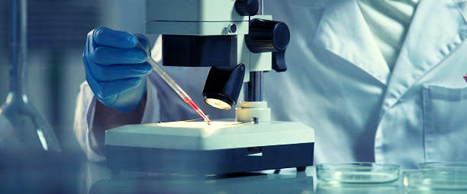

COMPENSATION, BENEFITS, AND DEADLINES

Compensation:
The County of Sacramento offers an excellent compensation and benefits program. The salary range for this position is $252,564.48 - $282,819.60 annually. In addition to the above salary, Forensic Pathologists certified in Neuropathology, Pediatric Pathology or other recognized specialties, shall receive Premium Pay in the amount of 10% of their base salary.

Forensic Pathologists assigned Standby shifts, shall receive 12.5% of their base salary for each hour assigned. On average, Standby time per Forensic Pathologist is 1,959 hours per year. This is for coverage, after hours and on weekends, for a week at a time. Duties include fielding calls regarding organ procurement, case triage and on rare occasions, responding to a scene of death.

The attractive benefits program includes:
Retirement - The County's Retirement plan is provided by the County Retirement Act of 1937 and is managed by the Sacramento County Employees' Retirement System.
Medical Insurance - Choice of HMO and High Deductible Health Plans (HDHP), to include Kaiser, Sutter, and Western Health Advantage.
Holidays - 13.5 paid holidays per year.
Vacation - Two to five weeks (based upon length of service) of paid vacation. Sick Leave - 15 days per year.
Flexible Spending Accounts - Employees may set aside funds on a pre-tax basis to pay for eligible medical and/or dependent care expenses.

Application procedure:
Please send Curriculum Vitae and letter of interest to: Dr. Jason Tovar, Chief Forensic Pathologist tovarj@saccounty.net | 916-874-9685

Upcoming filing deadlines:
Open until filled.

