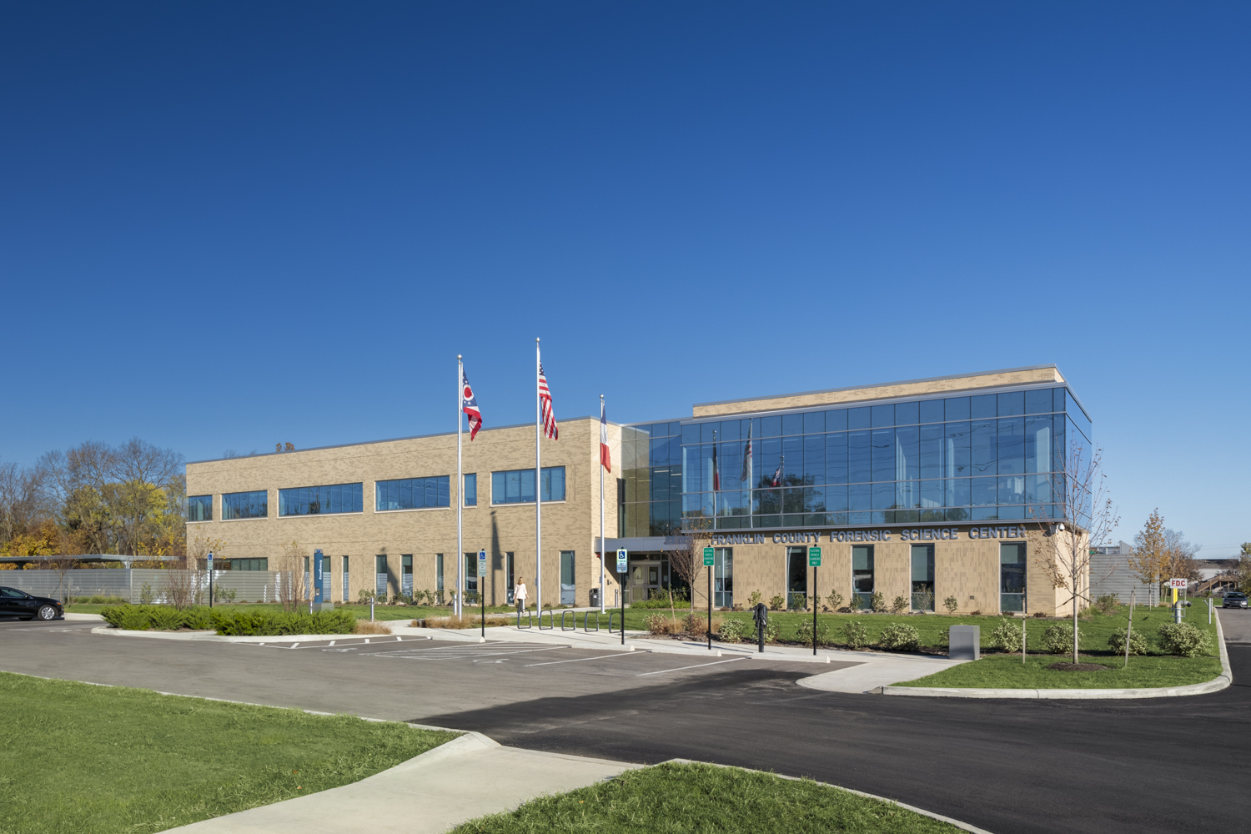

Franklin County Forensic Science Center

Deputy Coroner/ Forensic Pathologist

The Franklin County Coroner’s Office seeks an additional forensic pathologist to join our team of five who are board certified. We align ourselves with National Association of Medical Examiners (NAME) accreditation standards.
Qualified applicants will be expected to:
- Perform approximately 250-300 autopsy equivalents per year;
- determine the need for postmortem examination;
- perform autopsies and postmortem examinations and document findings in concise and accurate reports to determine cause and manner of death;
- collect evidence for law enforcement agencies;
- prepare reports of postmortem examinations and autopsies; case completion according to NAME standards;
- review medical records, police reports and toxicology results as required to accurately determine cause and manner of death;
- be on call one (1) week per month, including weekend examinations every fifth (5th) week
- attend and participate in departmental meetings;
- direct morgue technicians in preparation of photographs and radiographs;
- supervise the work of assigned morgue technician to ensure that autopsies are done in an appropriate manner;
- answer inquiries from relatives and other interested parties as to the cause and manner of death;
- offer professional consultation to outside agencies, including organ procurement organizations, criminal court officials and law enforcement and provide judicial testimony;
- direct medicolegal death investigators to ensure that pertinent information is received;
- participation in the QA process;
- teaching medical students, residents and students from local forensic science programs;
- participate in trauma conferences and Child Fatality Review meetings when required.
Our office receives about 3,200 reports of death annually and performs approximately 1,700 postmortem examinations annually (this number includes full autopsies and external examinations). We are supported by 10 medicolegal death investigators who respond to the majority of jurisdictional scenes and staff the office 24 hours a day, 7 days a week. The office has a dedicated in-house Forensic Toxicology laboratory (accredited by the American Board of Forensic Toxicology) and X-ray services ( Lodox, CT scan), as well as access to forensic dentists and forensic anthropologists. Due to our affiliation with multiple area medical centers, consultations with clinical specialists are easily obtained. In May, 2020 we moved into a 56,000 sq foot new state of the art forensic science center.
Columbus, Ohio
The office is located in Columbus, Ohio. Columbus is the 15th largest city in the United States with a population of 850,000. It has been listed as one of the Best Places for Business and Careers (Forbes 2013), and was ranked a top ten city by Relocate America (2010). Columbus offers the feel of a large city with the conveniences of smaller cities.
One of the best parts about Columbus is the relatively low cost of living compared to other large metro areas. While the average annual salary is only slightly below the national average, home sales prices, monthly rents and the overall cost of living are lower here than in other major metros around the country.
Columbus is a bustling place that doesn't lack for entertainment. The Short North Arts District is full of restaurants, shops, bars, concert venues, art galleries and more. The Gallery Hop, which takes place on the first Saturday of every month, is a great way to experience the artistic talent that Columbus has to offer. The Short North area is also home to North Market, a public market with more than 35 vendors offering diverse, local cuisine, fresh produce, gifts and more.
Columbus also encompasses many parks and museums, including COSI (Center of Science and Industry), the Museum of Art, the Columbus Zoo and Aquarium and the Scioto Mile riverfront park. Special events and festivals take place throughout the year, and during the fall, the region lives and breathes football. The pride and joy of the city is the Ohio State Buckeyes.
Minimum requirements:
- Must have graduated from an accredited school of medicine or osteopathy and obtain a current license to practice medicine in the state of Ohio prior to start date.
- Must have completed an accredited fellowship in forensic pathology and be eligible or certified.
- Pass a rigorous background check.
Knowledge, Skills, and Abilities:
Knowledge of principles and practices of forensic pathology, laws, rules, and regulations governing death investigation services. Team work, mutual respect, professionalism, affability and equanimity are critical. We have a team-oriented approach to case management. Must be able to communicate effectively orally and in writing; able to establish and maintain a positive professional working relationship with members of law enforcement agencies, as well as prosecuting and defense attorneys and carry the utmost respect for our decedents. Ability to operate personal computer, including experience with Microsoft Office programs (Word, Power Point, Outlook, etc.).
The benefit package includes outstanding health, dental, life insurance, and state retirement plan. Deputy Coroner / Forensic Pathologist salary is between $200,000 and $225,000, negotiable. There is an additional CME/professional fee allowance of $2,000 a year.

Contact:
To apply for this position candidates should submit a cover letter and copy of their CV via fax or email. Only those applicants selected for an interview will be contacted.
Anahi Ortiz, M.D.
Franklin County Coroner
2090 Frank Road
Columbus, Ohio 43223
614-525-5290
614-525-6002 (fax)
amortiz@franklincountyohio.gov

Associate Medical Examiner
Hillsborough County, Florida

Hiring Range

Commensurate with Experience
Job Summary/Essential Job Functions
The associate medical examiner will perform functions of a forensic pathologist, conducting post-mortem examinations, and associated work duties.

Requirements
At minimum, applicants must have an MD or DO degree, certification by the American Board of Pathology in Anatomic Pathology and Forensic Pathology, and eligibility for medical licensure in Florida. If the applicant is not Board certified at the time of hiring, certification in both Anatomic and Forensic Pathology should be completed within two years.

Duties and Responsibilities
- Performs primary functions of a forensic pathologist in accordance with industry standards to determine manner and cause of death in medical examiner cases
- Maintains all required licenses and accreditations consistent
with the industry standards
- Maintains individual continuing medical education and assures compliance with licensing and certification requirements
- Assists in the training of forensic pathology fellow, participate in teaching the University of South Florida pathology residents, and medical students
- Provides expert testimony in criminal and civil court
as requested

Benefits
Hillsborough County participates in the Florida Retirement System, and provides an excellent benefit package including:
- Paid continuing medical education expenses
- At least 4 weeks annual leave
- Short- and long-term disability
- 401(k)
- Medical, dental, and vision insurance
- Professional membership dues and professional licensing fees

About Hillsborough County Medical Examiner
- In 2019, our pathologists performed 1,272 autopsies, 737
external examinations, and 7,848 case reviews.
- The Hillsborough County Medical Examiner facility was built in 2008 and includes 3 separate administration, morgue, and toxicology buildings.
- The facility is home to 2 board-certified forensic toxicologists, a board-certified neuropathologist, 12 ABMDI-certified medicolegal death investigators, a genealogist, 8 autopsy technicians, and 2 experienced transcriptionists.
- The 10-acre campus can support a mass fatality contingency while maintaining daily operations. A designated area provides room for refrigerated trailers that can accommodate an additional 200 bodies.
- The facility can sustain on-site operations following a hurricane. It was built on high ground with two days’ worth of back-up power.

Human Resources

