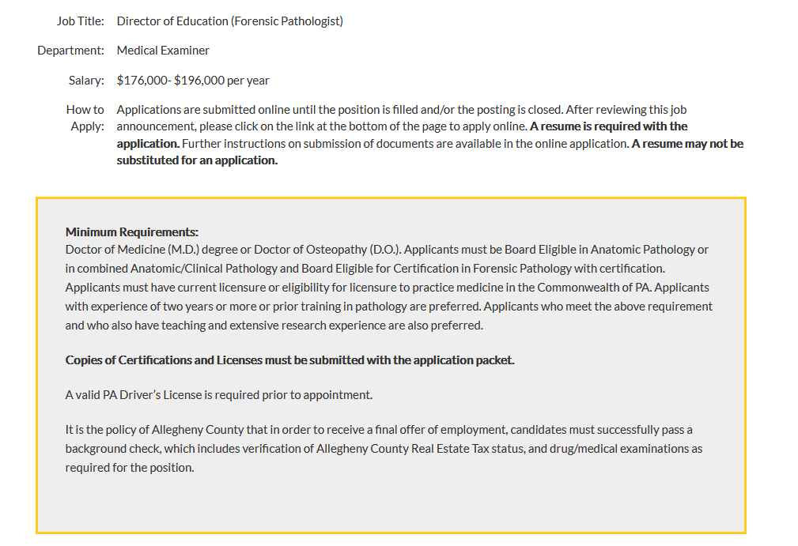

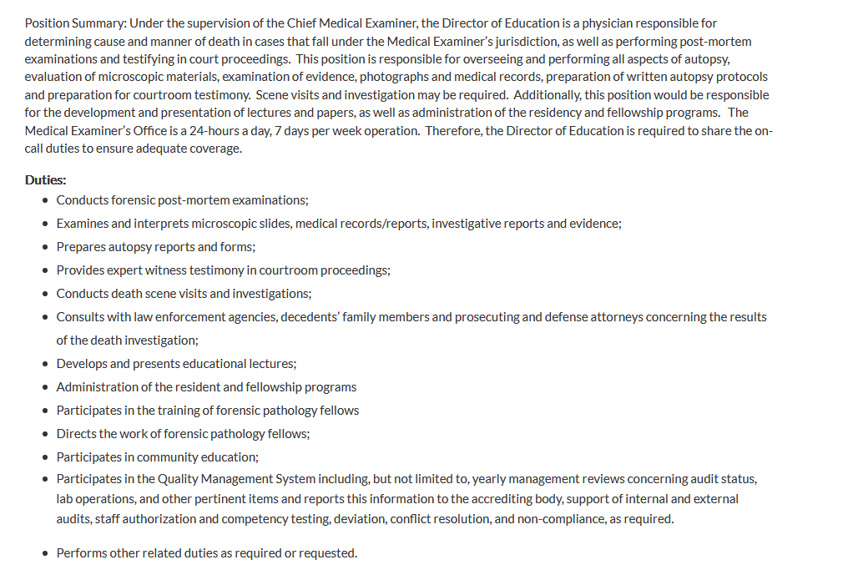



Reply to: Karl E. Williams MD, MPH [karl.williams@alleghenycounty.us](mailto:karl.williams@alleghenycounty.us)