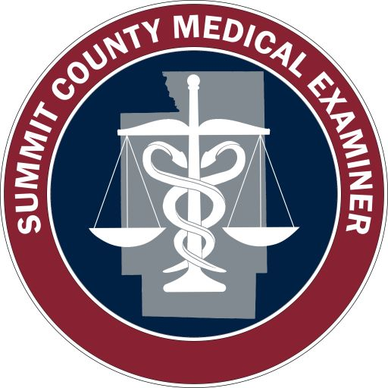
This posting is for a Deputy Medical Examiner at the
Summit County Medical Examiner’s Office,
85 N. Summit Street, Akron, Ohio 44308.

Apply for this position at https://jobs.summitoh.net

Deputy Medical Examiner

Position Details

Appointing Authority Summit County Executive Ilene Shapiro

Department/Division Executive, Medical Examiner's Office

Full Time/Part Time Full Time

Regular/Temporary Regular

Work Schedule The employee must be available to work a variety of hours and under a variety of conditions. On-call duties will be shared with three other forensic pathologists.

Normal Business Hours: Monday – Friday, 7:30 am to 4:00 pm.

Job Description The newly hired forensic pathologist would be joining 3 other board certified forensic pathologists at a NAME Accredited Office. The Summit County Medical Examiner’s Office serves a population of approximately 540,000 citizens and performs approximately 580 examinations and 170 records reviews each year.

We currently provide autopsy coverage for a neighboring County Coroner’s Office. The caseload would be divided between the 4 pathologists with call weeks every 4th week with rotating holiday schedules. No examinations are performed on Sundays, Christmas day, New Year’s Day or Thanksgiving Day. Our office has strong professional relationships with the medical community, criminal justice system and referring coroners. We employ a full time staff of ABMDI certified death investigators.

Under administrative direction; performs inquiries, examinations and testing of a medical nature to determine the mechanism, cause and manner of deaths brought to the attention of and entering the jurisdiction of the Medical Examiner’s office; supervises morgue personnel, collects physical evidence; assumes the duties and responsibilities of the Chief deputy Medical Examiner during an absence.

Required Qualifications Any combination of training or work experience which indicates possession of the skills, knowledge and abilities listed below.

Licensed to practice as a physician in the State of Ohio. Certification in anatomic pathology from the American Board of Pathology. A qualified individual must be Board eligible or certified in forensic pathology. Possession of a valid State of Ohio driver’s License. Requires the ability to access potential and/or hazardous environment, and transports self to the work site under various climatic conditions.

Preferred Qualifications

Pre-Employment Testing
Requirements Criminal Background Check, Pre-employment Drug and Alcohol Testing

Work Environment

Physical Demands

Licensing/Certification State of Ohio medical license, initial Certification by the American Board of Pathology in Anatomic Pathology with eligibility or initial board certification in Forensic Pathology (board certification must be obtained in Forensic Pathology within 2 years of hire). Valid Ohio driver’s license.

Additional Information Summit County is an excellent place to live, work and play. We have a thriving County Metro park system and the Cuyahoga Valley National Park that provide opportunities for hiking and other outdoor activities. We are home to the Akron Rubber Ducks, a minor league baseball team who play in Canal Park in downtown Akron. There are numerous restaurants and entertainment venues within the City and surrounding community and we are within a 1-2 hour drive from major metropolitan areas (Cleveland, Columbus and Pittsburgh) who offer additional larger entertainment venues.

Job Duty Name Deputy Medical Examiner Job Duties

Description of Job Duty The duties listed below are intended to depict tasks performed by this classification.

Performs postmortem examinations and assisted by morgue technicians; removes tissue sections for histologic examination and reviews histologic slides; assumes the responsibilities of the Chief Deputy Medical Examiner during an absence. Supervises investigative and laboratory personnel (e.g., plans, schedules, assigns work, trains, evaluates, etc.); directs assigned state, federal and other medical and/or investigative personnel; assists in the development of directives, policies, and procedures regarding autopsies. Communicates findings and interpretations to law enforcement agencies, lawyers, physicians, other professionals and members of decedents’ families; testifies in court as an expert witness, conducts scene investigations to obtain additional data; plans for, researches subject, and participates in the training of medical examiner personnel, the general public, law enforcement agencies (e.g. medical autopsy procedures and new methods; handling and preserving evidence, drugs, etc.; safety practices and procedures, etc.). Analyses tests and investigative data; prepares reports and other documentation as required; makes determination of death and submit for review, verification and approval.

Requisition Details

Requisition Number C/U - 1452021-P

Working Title Deputy Medical Examiner

Posting Type External/Public Posting

Number of Vacancies 1

Advertised Salary $171,641.60 – $180,000.00 annually

Open Date 09/28/2021

Close Date 12/31/2021

Open Until Filled No

Special Instructions
Summary

Supplemental Questions

Required fields are indicated with an asterisk (*).

1. * Do you currently possess a certification in anatomic pathology from the American
Board of Pathology?
Yes
No

2. * Are you Board eligible or certified in forensic pathology?
Yes
No

3. * Do you have a valid State of Ohio vehicle operator's license?
Yes
No

Documents Needed to Apply

Required Documents

Optional Documents
1. Resume
2. Cover Letter

