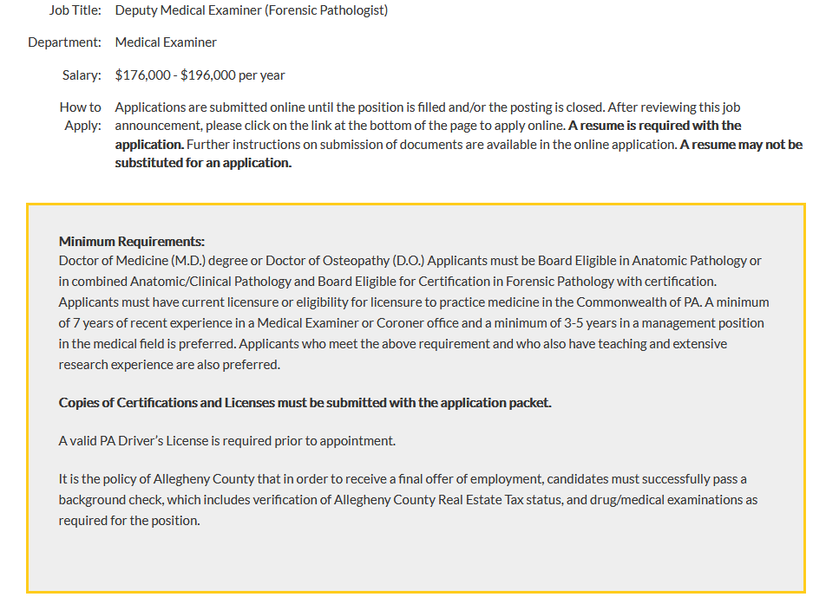

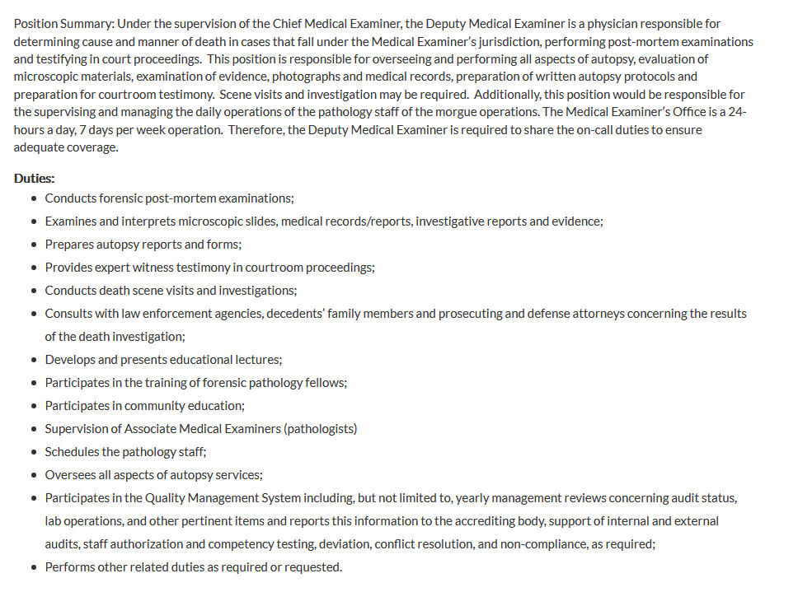



**Reply to Karl E. Williams MD, MPH** [**karl.williams@alleghenycounty.us**](mailto:karl.williams@alleghenycounty.us)