BEXAR COUNTY MEDICAL EXAMINER’S OFFICE
Deputy Medical Examiner and Locums Tenens
Position Opening

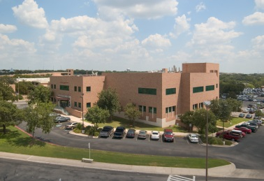

The Bexar County Medical Examiner's Office has two openings for a Deputy Medical Examiner and is seeking qualified individuals to fill these positions. We also have Locums Tenens opportunities on an interim basis, providing both weekday and/or weekend coverage with flexible scheduling. The NAME accredited office is located in San Antonio, TX and is staffed by seven full-time Board Certified Forensic Pathologists. The BCMEO investigates approximately 14,000 cases a year, taking jurisdiction on approximately 3,000. In 2019, the office performed 1,835 autopsy examination, 1,175 external inspections and 1,220 scene investigations. In addition to the Medical Examiners, the office is staffed by 18 investigators including the Chief and two clerks, 11 autopsy technicians, 8 clerical personnel and 2 administrators. The office also houses an ABFT accredited full service postmortem toxicology laboratory overseen by a Ph.D. level Chief Toxicologist as well as an ACGME accredited forensic pathology fellowship program.
The BCMEO is located in Central Texas, just southeast of the beautiful Texas Hill Country. San Antonio has a low cost of living and boasts the famed River Walk, our annual Fiesta celebration, and the UNESCO World Heritage site Missions National Historical Park. The city offers activities for the entire family including SeaWorld, Fiesta Texas amusement park, and various shopping areas as well as being home to both the San Antonio Spurs and the San Antonio FC professional soccer team.
BCMEO Deputy Medical Examiners are responsible for performing death investigations, autopsy examinations and testifying in legal proceedings. Qualifications for the position include current Board certification in Forensic Pathology by the American Board of Pathology or the ability to obtain Board certification within two years of hire and a Texas medical license. The BCMEO offers a competitive salary ($190,000-$240,000) dependent upon education and experience with full county benefits (summary available at: https://www.bexarsidekick.org/153/Employee-Benefits).
For further information, please contact:
Dr. Kimberley Molina, Chief Medical Examiner, 210-335-4053 or kmolina@bexar.org
Or apply online at:
https://www.governmentjobs.com/careers/bexarcountytx

