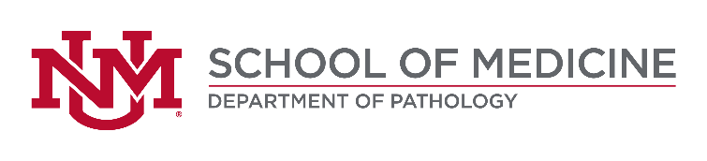

THE UNIVERSITY OF NEW MEXICO SCHOOL OF MEDICINE DEPARTMENT OF PATHOLOGY
OFFICE OF THE MEDICAL INVESTIGATOR

The Department of Pathology at the University of New Mexico is seeking two (2) forensic pathologists at the Assistant, Associate or Full Professor level to join ten (10) board certified forensic pathologists at the New Mexico Office of the Medical Investigator. These individuals will perform medicolegal and hospital autopsies, teach medical students, pathology residents and forensic pathology fellows, and will be encouraged to develop a program of scholarly inquiry.

The Office of the Medical Investigator is a statewide, centralized, academically based medicolegal death investigative agency for New Mexico. This agency investigates approximately 7,000 of the 18,000 deaths that occur each year in New Mexico, and performs approximately 2,000 autopsies and 2,500 whole body CT exams each year. The office has been NAME accredited since 1976. When fully staffed, the pathologist caseload is compliant with NAME phase I standards. Detailed death investigation data (1977-present) is recorded in an electronic database. The office occupies a state-of-the-art facility completed in 2010 including a fully Biosafety Level-3 autopsy laboratory that houses both CT and MR Scanners. New faculty will be trained in the incorporation of imaging technology into daily practice. The office has faculty providing expertise in neuropathology, anthropology, odontology, epidemiology, and radiology and forensic imaging. The OMI forensic pathology fellowship program has 4 slots/year and has trained 100 fellows who are in practice throughout the US and internationally.

Minimum requirements: 1) MD degree or equivalent, 2) Board certified/eligible in Anatomic Pathology, 3) Board certified/eligible in Forensic Pathology or currently in a Forensic Pathology Fellowship, 4) Eligible to work in the US.

Desirable qualifications: 1) Experience or training in a subspecialty of medicine, pathology or science applicable to forensic pathology, 2) Experience training forensic fellows and pathology residents in autopsy pathology using both hospital and medicolegal autopsies, 3) Experience teaching medical students, 4) Evidence of scholarly productivity, 5) Evidence of public speaking and writing skills.

Salary is based on academic rank and years in service.

Applications will be accepted until the position is filled. For best consideration, apply by 12/2/2019, however, the position will remain open until filled.

For complete details of this position or to apply, please visit this website: https://UNMJobs.unm.edu and search for Req8263

In addition to completing the UNMJobs required information, a complete application will include a CV and cover letter/letter of interest. The cover letter must address each requirement or qualification and how it relates to the position. The application materials must include the names, addresses, and telephone numbers of three references; candidates will be consulted before references are contacted. Additionally, this position may be subject to criminal records screening in accordance with New Mexico law. If criminal records screening is mandated, clearance by the New Mexico Department of Health is required as a condition of employment.

For additional information, visit our web site at: http://pathology.unm.edu/ or contact Ruth Kief, Operations Manager, Department of Pathology, telephone: 505 272-9877, email: rkief@salud.unm.edu

The University of New Mexico is an EEO/AA employer and educator.

UNM's confidentiality policy ("Disclosure of Information about Candidates for Employment," UNM Board of Regents' Policy Manual 6.7), which includes information about public disclosure of documents submitted by applicants, is located at https://policy.unm.edu/regents-policies/section-6/6-7.html

